|  |  |
| --- | --- |
| Digital forensics crucial for investigations&#39;  bANK mANAGEMENT sYSTEM  Zack Bank | Project Report  This document contains the report of banking system to elaborate the project.  Zafeer Hafeez  Fa-2020-BSCS-022 |

Table of Contents

Introduction 2

Goal 2

Deployment 2

Project Explanation 2

File Management 2

Execution of Program 3

Login 3

Employee 4

menuHandler() 4

New Account 4

Display All Accounts 6

Update Account 7

Delete Account 9

Get Information 9

Deposit Amount 10

Withdraw Money 11

Customer 11

menuHandler() 11

Mini Statement 12

Conclusion 12

# Introduction

Banking System is developed in C++ to replaced manual System by a computerized system. This system allows to create a new account and allows to deposit and withdrawal amount facilities. Name of this banking system is **Zack**.

# Goal

To design and build a banking management system in C++ using learned Object-Oriented techniques.

# Deployment

The built system will be deployed in a bank, so should work from both user and bank employee’s perspectives.

# Project Explanation

## File Management

We are using the following naming system for our project:





resources

bin



header.h

transection.h

customInput.h

employee.h

bank.h

customer.h

lib

main.exe

bin

main.cpp

lib



transection.dat

Customer.dat

resources

## Execution of Program

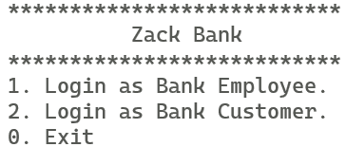

## Login

If we choose 1 then it will ask for employee credentials which are

Name: user

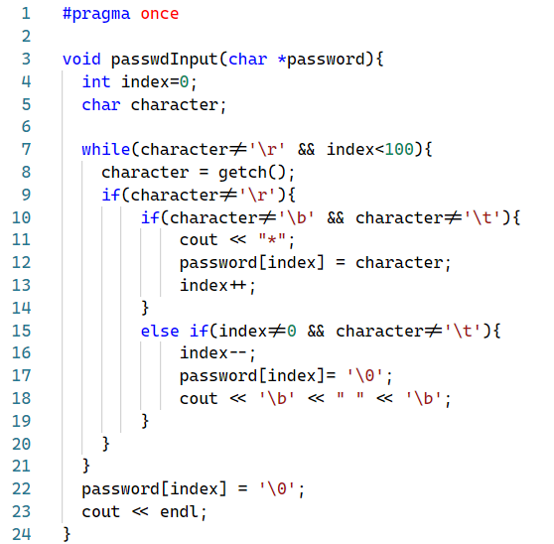Password: zack123

Interesting thing is, the password input. **passwdInput()** is responsible for this functionality and it is defined in customInput.h.

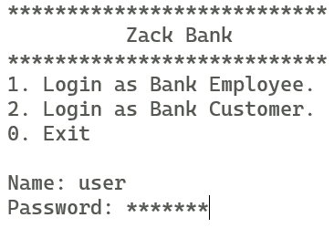

## Employee

### menuHandler()

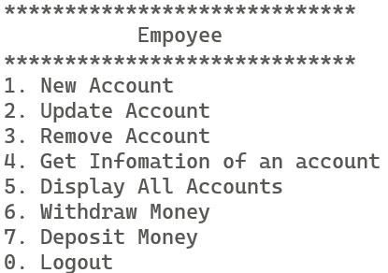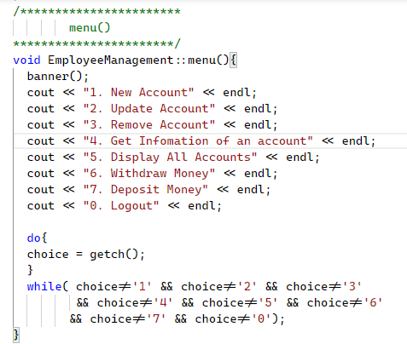

### New Account

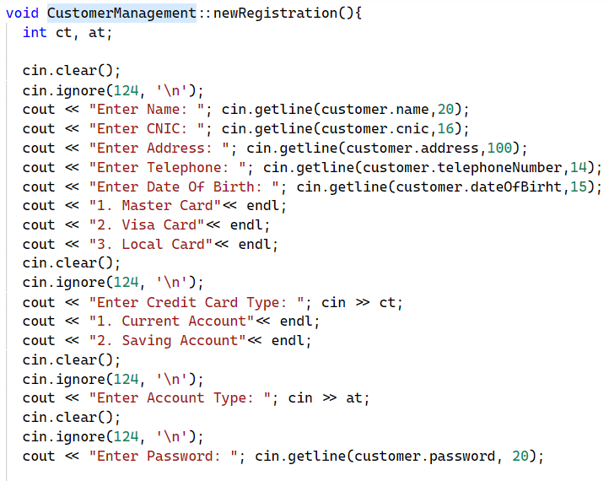

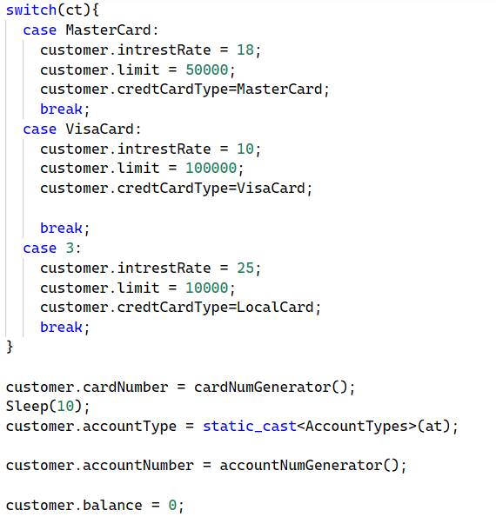

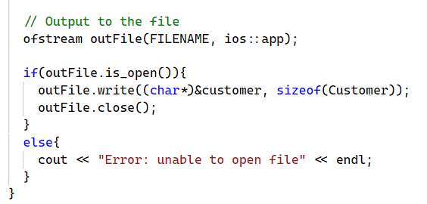

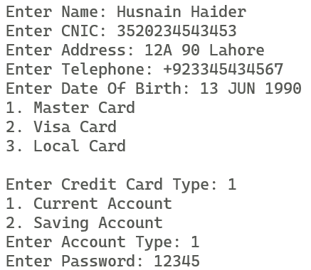

### Display All Accounts



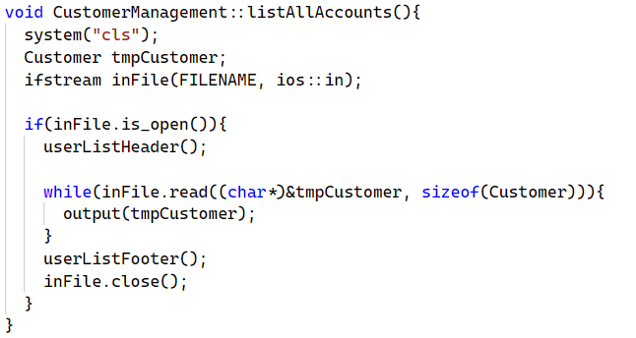

### Update Account

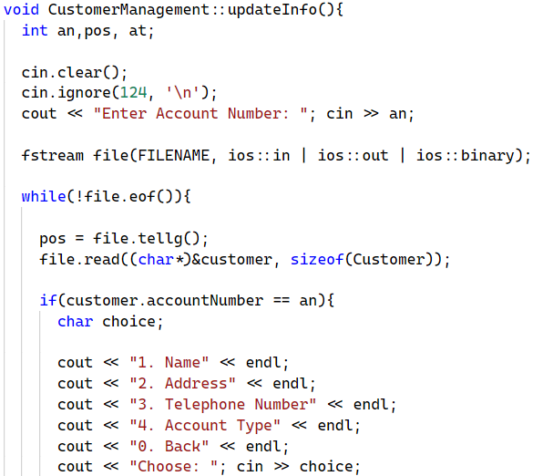

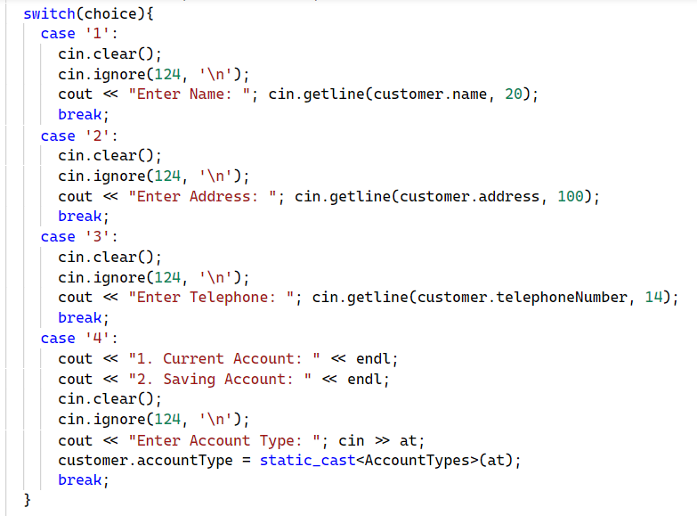

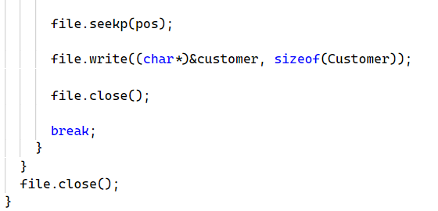

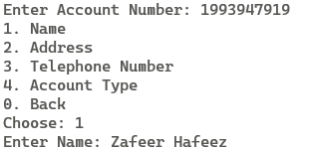

### Delete Account

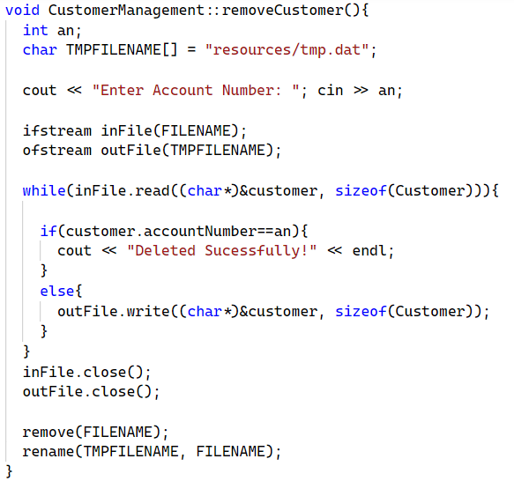

### Get Information

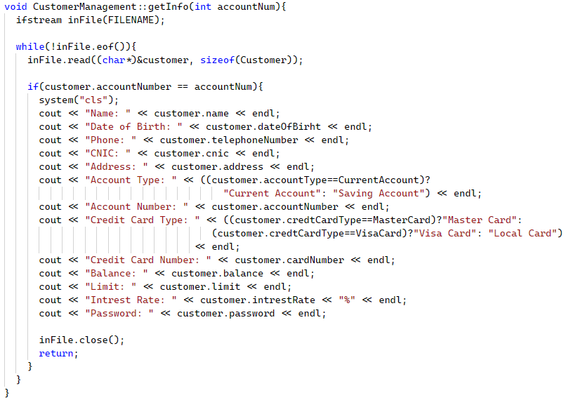

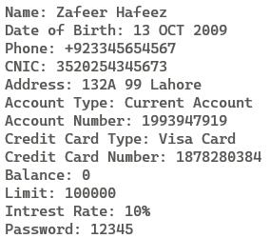

### Deposit Amount

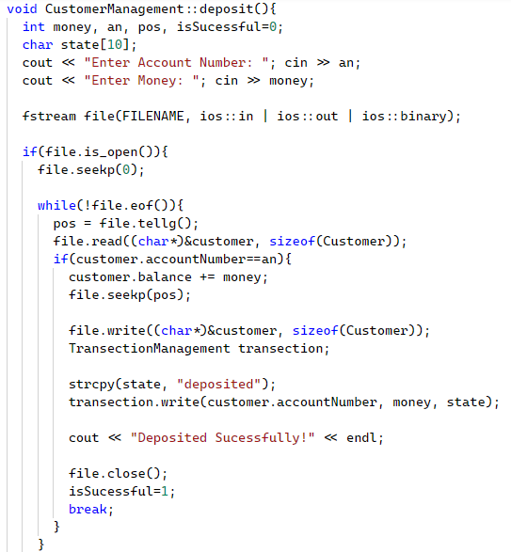

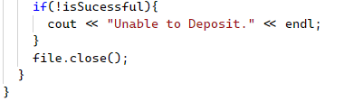



### Withdraw Money

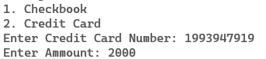

## Customer

### menuHandler()

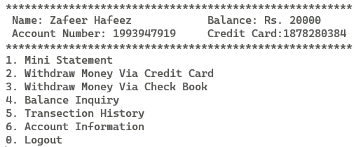

### Mini Statement

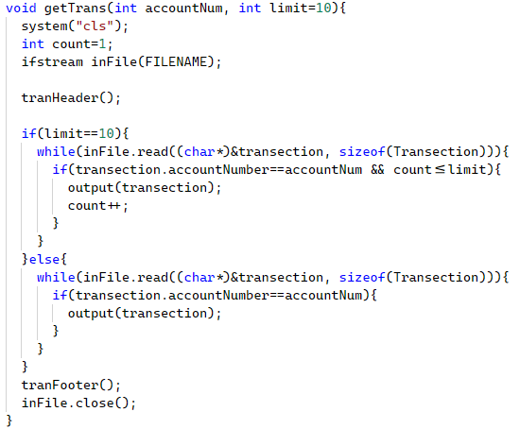

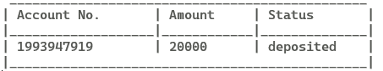

All other options are same as in employee.

# Conclusion

This project can be a good alternative to manual system of banking and can be even more effective than the old one. We can add more features in future which relief both the customers and the employees.